Lab Report No 06

**Interfacing PHP with MySQL**

**_____________________**

**403L-Database Management Systems**

**Department of Computer System Engineering**

**University of Engineering and Technology Peshawar**

Submitted to: **Engr. Sumayyea Salahuddin**

Submitted by: **Muhammad Saad**

Reg ID: **21PWCSE1997**

**DCSE, Batch 23, Section “B”**



Student Signature: ____________

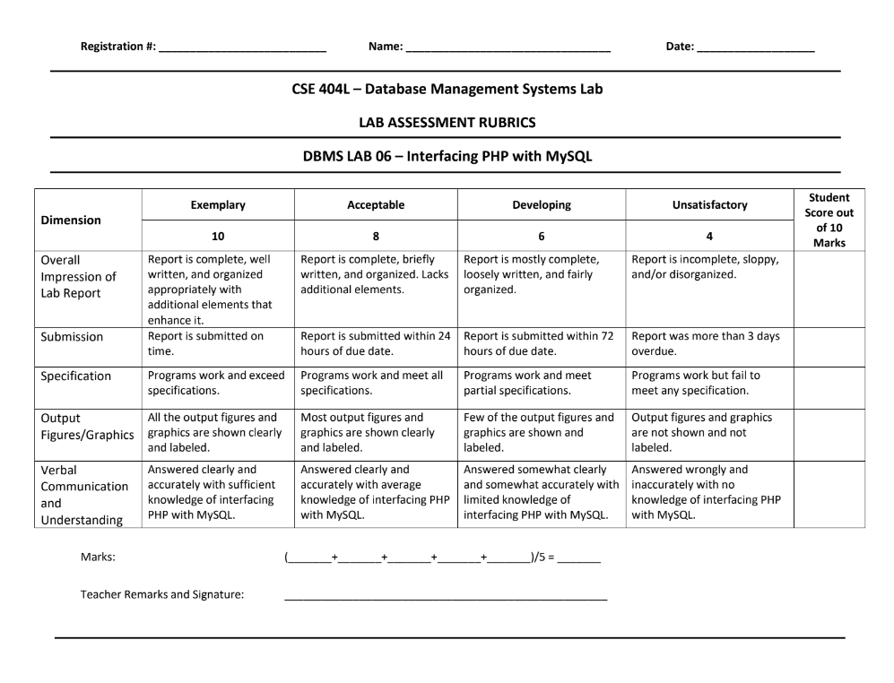

21pwcse1997 Muhammad Saad17/5/2024

**Lab # 06: Interfacing PHP with MySQL**

**Objective:**

This lab aims at the understanding of:

* Type of MySQL Drivers in PHP
* PHP-MySQL Interfaces

**Tasks 6.1**

**Q1: Complete Example 3 by providing a suitable query, its result, and then freeing result variable.**

**A:**

<!DOCTYPE html>

<html lang="en">

<head>

<meta charset="UTF-8">

<meta name="viewport" content="width=device-width, initial-scale=1.0">

<title>Document</title>

<?php

*$servername* = "localhost";

*$username* = "root";

*$password* = "";

*$database* = "myDatabase";

*$conn* = new mysqli(*$servername*, *$username*, *$password*, *$database*);

?>

</head>

<body>

<?php

if (*$conn*->connect_error) {

die("Connection failed: " . *$conn*->connect_error);

}

echo "<h4>Connected successfully</h4>";

*$insertQuery* = "INSERT INTO employee (empID, name, depID)

VALUES ('21345', 'Kamran', '1')";

*$selectQuery* = "SELECT * FROM employee";

*$conn*->query(*$insertQuery*);

*$result* = *$conn*->query(*$selectQuery*);

if (*$result*->num_rows > 0) {

while (*$row* = *$result*->fetch_assoc()) {

echo "ID: " . *$row*["empID"] . " - Name: " . "<b>{*$row*["name"]}</b>". "<br>";

}

} else {

echo "No records found.";

}

*$result*->free_result();

*$conn*->close();

?>

</body>

</html>

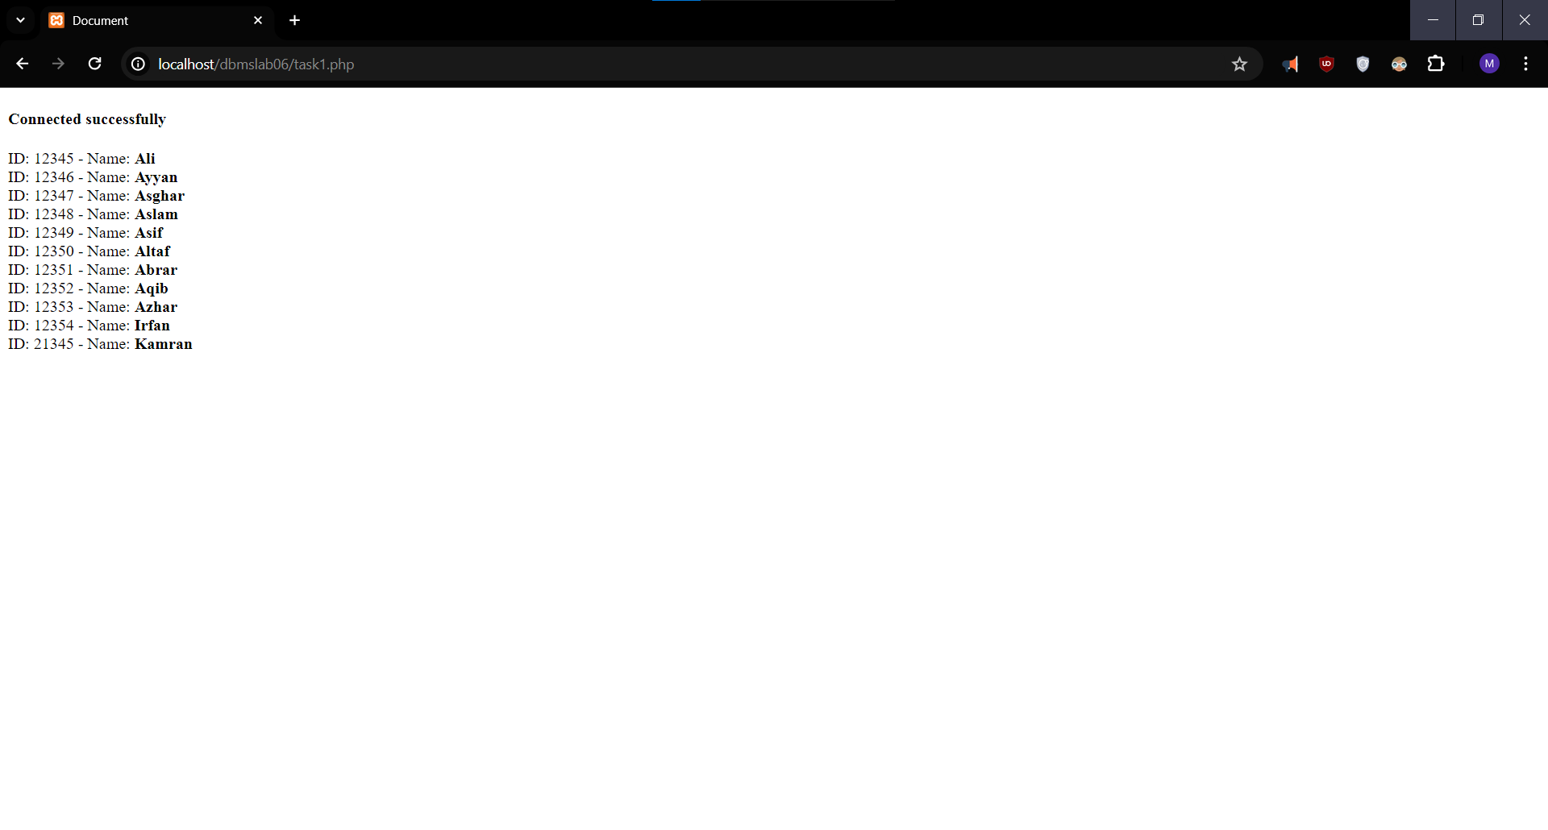

Fetching data from database and then freeing the result afterwards

**Tasks 6.2**

**Q: Write PHP-MYSQLI Object-Oriented interface script that perform insert, update and delete.**

**Ans**

<?php

*$servername* = "localhost";

*$username* = "root";

*$password* = "";

*$database* = "myDatabase";

*$conn* = new mysqli(*$servername*, *$username*, *$password*, *$database*);

if (*$conn*->connect_error) {

die("Connection failed: " . *$conn*->connect_error);

}

//Insert

if (*$_SERVER*["REQUEST_METHOD"] === "POST") {

if (*isset*(*$_POST*["name"]) && *isset*(*$_POST*["depID"])) {

*$name* = *$_POST*["name"];

*$depID* = *$_POST*["depID"];

*$insertQuery* = "INSERT INTO department (name, depID) VALUES ('$name', '$depID')";

*$conn*->query(*$insertQuery*);

}

}

//Update

if (*$_SERVER*["REQUEST_METHOD"] === "POST") {

if (*isset*(*$_POST*["update_depID"]) && *isset*(*$_POST*["new_name"])) {

*$updateDepID* = *$_POST*["update_depID"];

*$newName* = *$_POST*["new_name"];

*$updateQuery* = "UPDATE department SET name = '$newName' WHERE depID = '$updateDepID'";

*$conn*->query(*$updateQuery*);

}

}

//Delete

if (*$_SERVER*["REQUEST_METHOD"] === "POST") {

if (*isset*(*$_POST*["delete_depID"])) {

*$deleteDepID* = *$_POST*["delete_depID"];

*$deleteQuery* = "DELETE FROM department WHERE depID = '$deleteDepID'";

*$conn*->query(*$deleteQuery*);

}

}

*$selectQuery* = "SELECT * FROM department";

*$result* = *$conn*->query(*$selectQuery*);?>

<!DOCTYPE html>

<head>

<title>DBMS Lab Project</title>

</head>

<body>

<form method="post" action=''>

Name: <input type="text" name="name"><br>

Email: <input type="number" name="depID"><br>

<input type="submit" value="Add User">

</form>

<br><br><br>

<form method="post" action="">

Department ID to update: <input type="number" name="update_depID"><br>

New Name: <input type="text" name="new_name"><br>

<input type="submit" value="Update">

</form>

<br><br><br>

<form method="post" action="">

Department ID to delete: <input type="number" name="delete_depID"><br>

<input type="submit" value="Delete">

</form>

<br><br><br>

<table>

<tr>

<th>Name</th>

<th>Department ID</th>

</tr>

<?php

if (*$result*->num_rows > 0) {

while (*$row* = *$result*->fetch_assoc()) {

echo "<tr>";

echo "<td>" . *$row*["depID"] . "</td>";

echo "<td>" . *$row*["name"] . "</td>";

echo "</tr>";

}

} else {

echo "<tr><td colspan='3'>No records found.</td></tr>";

}

?>

</table>

</body>

</html>

<?php

*$conn*->close();

?>

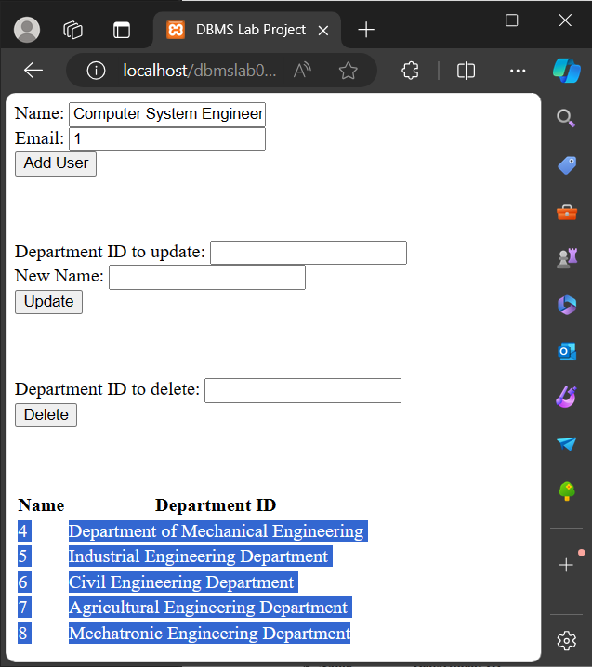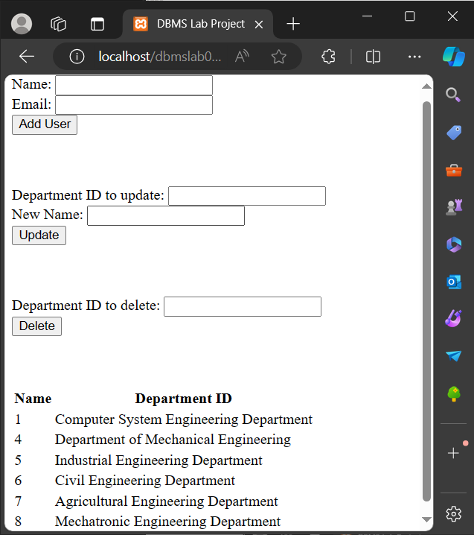

Insert Query in PHP

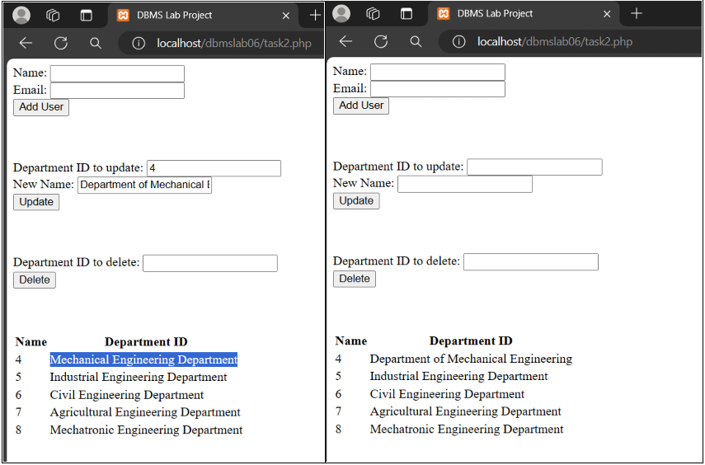

Update Query using PHP

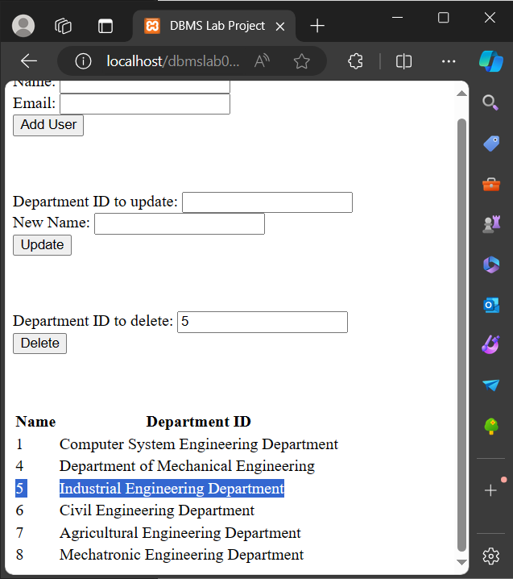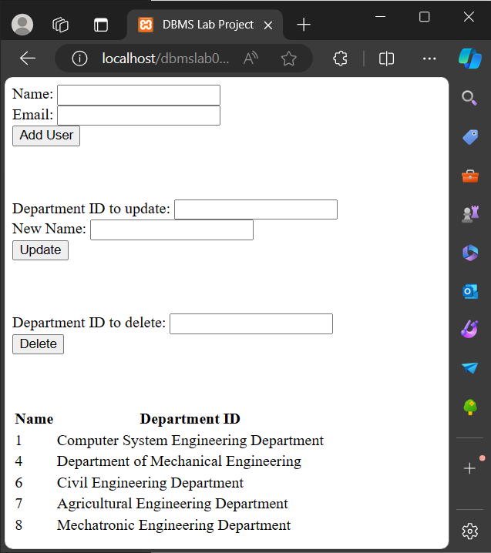Delete Query in PHP

**Tasks 6.3**

**Q: Perform Task 6.2 using PHP-PDO (PHP Data Objects) interface.**

**Ans**

<?php

*$host* = 'localhost';

*$dbname* = 'myDatabase';

*$username* = 'root';

*$password* = '';

try {

*$pdo* = new PDO("mysql:host=$host;dbname=$dbname", *$username*, *$password*);

*$pdo*->setAttribute(PDO::ATTR_ERRMODE, PDO::ERRMODE_EXCEPTION);

if (*$_SERVER*["REQUEST_METHOD"] === "POST") {

if (*isset*(*$_POST*["name"]) && *isset*(*$_POST*["depID"])) {

*$name* = *$_POST*["name"];

*$depID* = *$_POST*["depID"];

*$stmt* = *$pdo*->prepare("INSERT INTO department (name, depID) VALUES (?, ?)");

*$stmt*->execute([*$name*, *$depID*]);

}

}

if (*$_SERVER*["REQUEST_METHOD"] === "POST") {

if (*isset*(*$_POST*["update_depID"]) && *isset*(*$_POST*["new_name"])) {

*$updateDepID* = *$_POST*["update_depID"];

*$newName* = *$_POST*["new_name"];

*$sql* = "UPDATE department SET name = :newName WHERE depID = :updateDepID";

*$statement* = *$pdo*->prepare(*$sql*);

*$statement*->bindParam(":newName", *$newName*);

*$statement*->bindParam(":updateDepID", *$updateDepID*);

*$statement*->execute();

}

}

if (*$_SERVER*["REQUEST_METHOD"] === "POST") {

if (*isset*(*$_POST*["delete_depID"])) {

*$deleteDepID* = *$_POST*["delete_depID"];

*$sql* = "DELETE FROM department WHERE depID = :deleteDepID";

*$statement* = *$pdo*->prepare(*$sql*);

*$statement*->bindParam(":deleteDepID", *$deleteDepID*);

*$statement*->execute();

*$rowCount* = *$statement*->rowCount();

if (*$rowCount* > 0) {

echo "Department with depID $deleteDepID has been deleted.";

} else {

echo "No department found with depID $deleteDepID.";

}

}

}

*$stmt* = *$pdo*->query("SELECT * FROM department");

*$departments* = *$stmt*->fetchAll(PDO::FETCH_ASSOC);

} catch (PDOException *$e*) {

die("Error: " . *$e*->getMessage());}?>

<!DOCTYPE html>

<html>

<head>

<title>PHP PDO Example</title>

</head>

<body>

<form method="post" action=''>

Name: <input type="text" name="name"><br>

Email: <input type="number" name="depID"><br>

<input type="submit" value="Add User">

</form>

<br><br><br>

<form method="post" action="">

Department ID to update: <input type="number" name="update_depID"><br>

New Name: <input type="text" name="new_name"><br>

<input type="submit" value="Update">

</form>

<br><br><br>

<form method="post" action="">

Department ID to delete: <input type="number" name="delete_depID"><br>

<input type="submit" value="Delete">

</form>

<br><br><br>

<table>

<tr>

<th>ID</th>

<th>Name</th>

<th>Email</th>

</tr>

<?php foreach (*$departments* as *$department*): ?>

<tr>

<td><?= *$department*['depID'] ?></td>

<td><?= *$department*['name'] ?></td>

</tr>

<?php endforeach; ?>

</table>

</body>

</html>

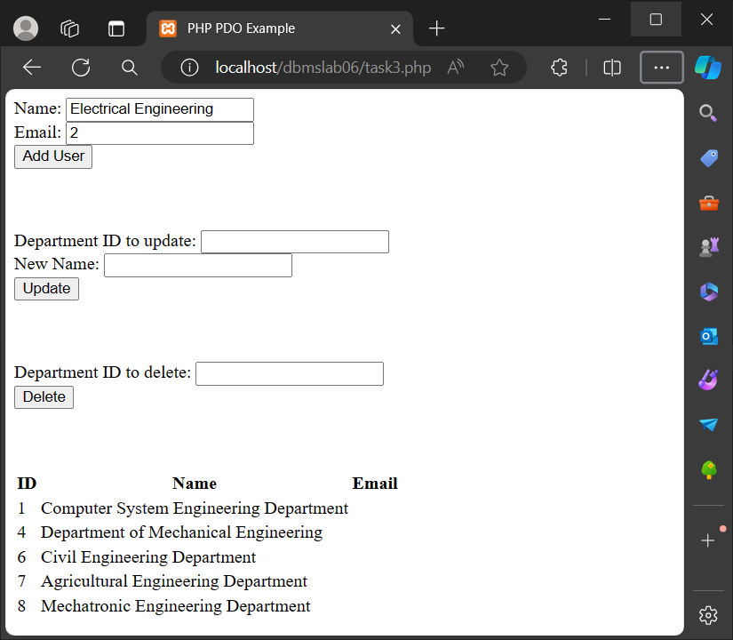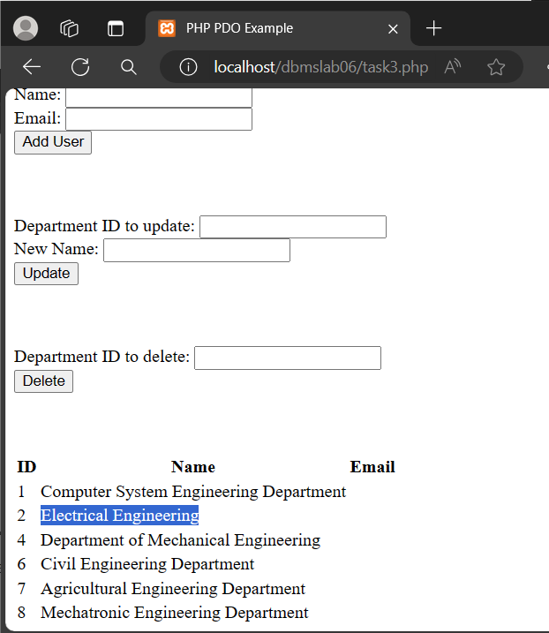

Insert Query in PHP

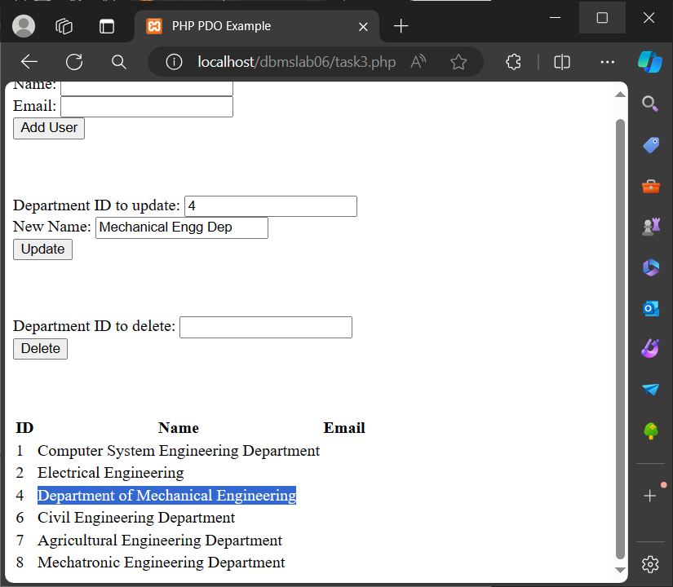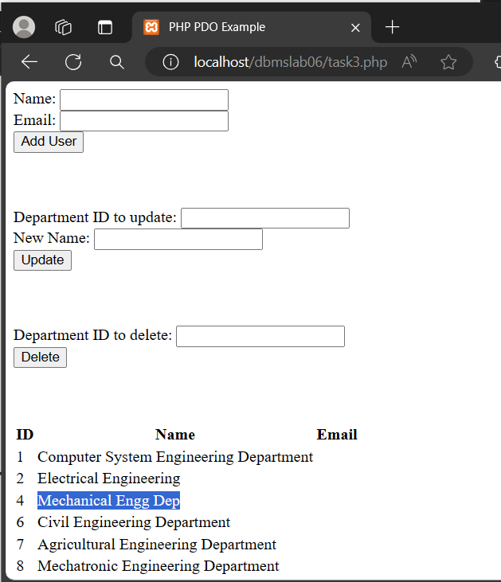Update Query using PHP

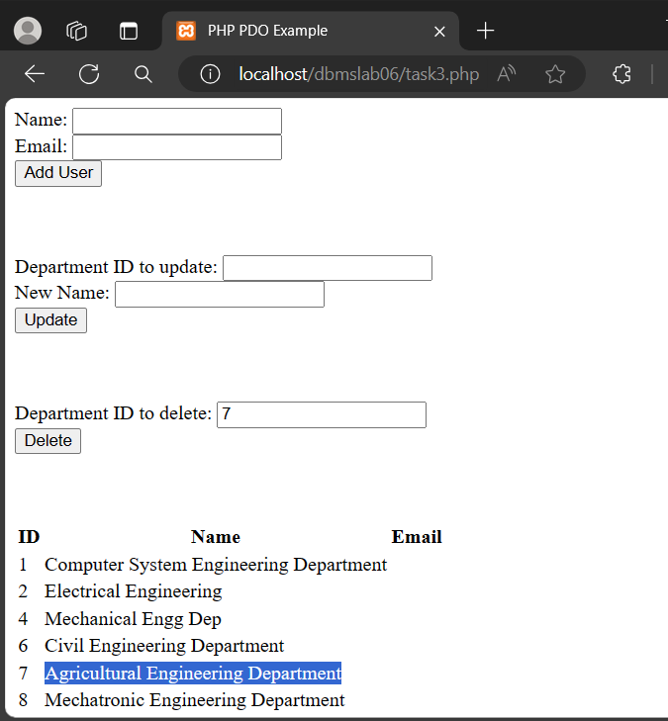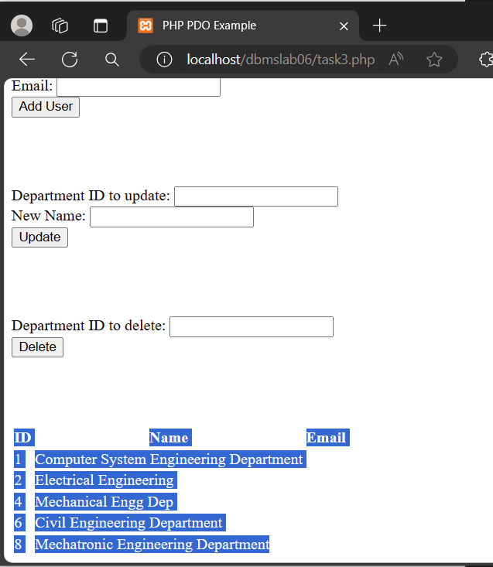Delete Query in PHP

**Tasks 6.4**

**Q: Perform Task 6.2 using LARAVEL.**

**A:**

<?php

namespace App\Http\Controllers;

use App\Models\Product;

use Illuminate\Http\Request;

class ProductController extends Controller

{

public function index(){

*$p* = Product::all();

return view('product.index', ['p' => *$p*]);

}

public function create() {

return view('product.create');

}

public function store(Request *$request*) {

*$data* = *$request*->validate([

'name' => 'required',

'qty' => 'required|numeric',

'price' => 'required|decimal:0,2',

'description' => 'nullable',

]);

*$newProduct* = Product::create(*$data*);

return redirect(route('product.index'));

}

}

Controller for table ‘product’

<?php

namespace App\Models;

use Illuminate\Database\Eloquent\Factories\HasFactory;

use Illuminate\Database\Eloquent\Model;

class Product extends Model

{

public *$table* = 'product';

use HasFactory;

protected *$fillable* = [

'name',

'qty',

'price',

'description'

];

}

Model for table ‘product’

<?php

use App\Http\Controllers\ProfileController;

use App\Http\Controllers\ProductController;

use Illuminate\Support\Facades\Route;

Route::get('/', function () {

return view('welcome');

});

Route::get('/dashboard', function () {

return view('dashboard');

})->middleware(['auth', 'verified'])->name('dashboard');

Route::middleware('auth')->group(function () {

Route::get('/profile', [ProfileController::class, 'edit'])->name('profile.edit');

Route::patch('/profile', [ProfileController::class, 'update'])->name('profile.update');

Route::delete('/profile', [ProfileController::class, 'destroy'])->name('profile.destroy');

});

Route::get('/product', [ProductController::class, 'index'])->name('product.index');

Route::get('/product/create', [ProductController::class, 'create'])->name('product.create');

Route::post('/product', [ProductController::class, 'store'])->name('product.store');

require __DIR__.'/auth.php';

Routes for our project

<!DOCTYPE html>

<html lang="en">

<head><title>Document</title></head>

<body>

<h1>Create a product</h1>

<form action="{{route('product.store')}}" method="post">

@csrf

@method('post')

<div>

<label for="name">Name</label>

<input type="text" name="name" placeholder="Name">

</div>

<div>

<label for="qty">Quantity</label>

<input type="text" name="qty" placeholder="Quantity">

</div>

<div>

<label for="name">Price</label>

<input type="text" name="price" placeholder="Price">

</div>

<div>

<label for="name">Description</label>

<input type="text" name="description" placeholder="Description">

</div>

<div>

<input type="Submit" name="" value="Submit">

</div>

</form>

</body>

</html>

View for our Form

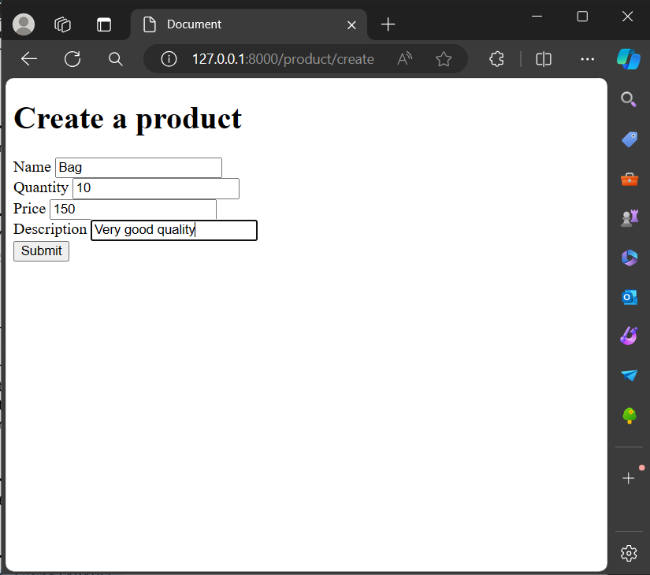

<!DOCTYPE html>

<html lang="en">

<head>

<meta charset="UTF-8">

<meta name="viewport" content="width=device-width, initial-scale=1.0">

<meta http-equiv="X-UA-Compatible" content="ie=edge">

<title>Document</title>

</head>

<body>

<h1>Product</h1>

<div>

<table border=1>

<tr><th>ID</th>

<th>Name</th>

<th>Quantity</th>

<th>Price</th>

<th>Description</th></tr>

@foreach ($p as $product)

<tr><td>{{$product->id}}</td>

<td>{{$product->name}}</td>

<td>{{$product->qty}}</td>

<td>{{$product->price}}</td>

<td>{{$product->description}}</td>

</tr>

@endforeach

</table>

</div>

</body>

</html>

View for showing the data

Taking data from user

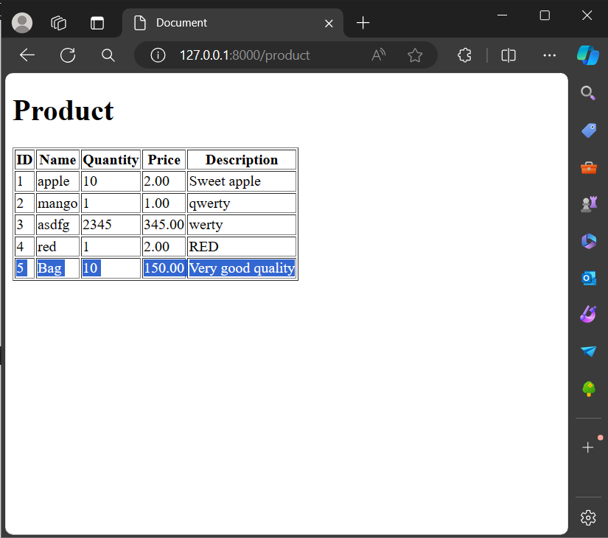Product has been added

________________________________________________________________________________________________________________________________________________________